Jenkins task for Day-03.

1) Create one jenkins job using the below code and create three stages.
stage1: Git clone to download the source code.
Here what we did , by using the below command ,
We created job name as v-profile and link clone .and save and success and need to check in local Jenkins server as well
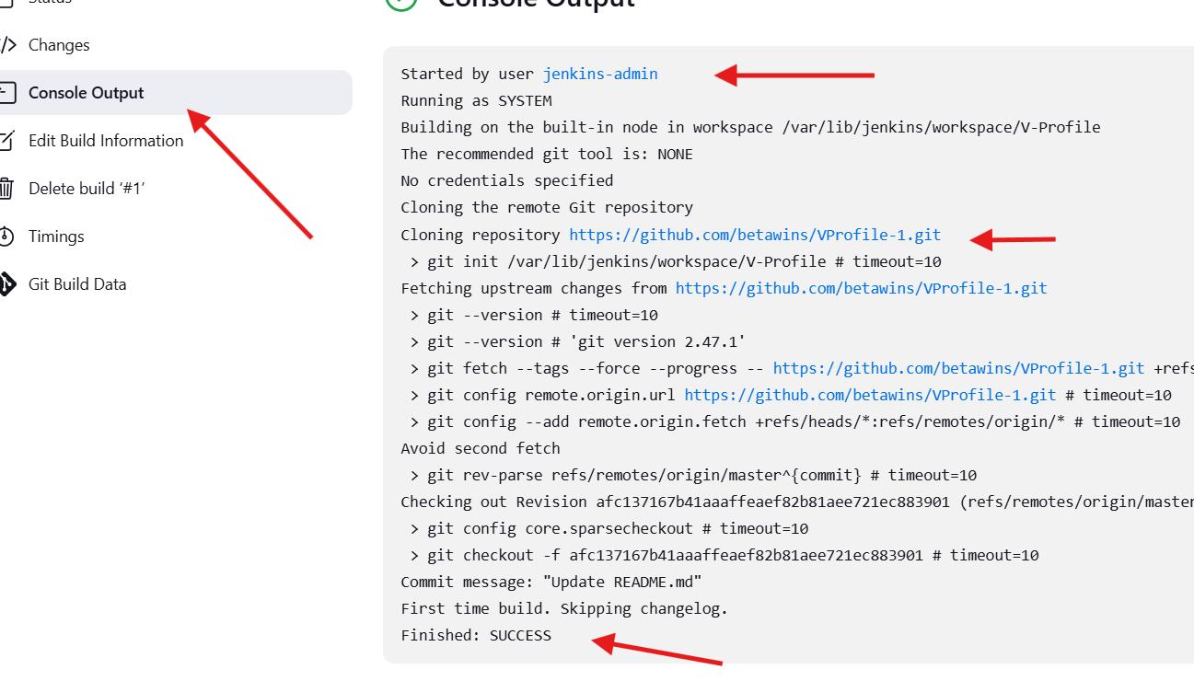
We created job name as v-profile and link clone .and save and success and need to check in local Jenkins server as well

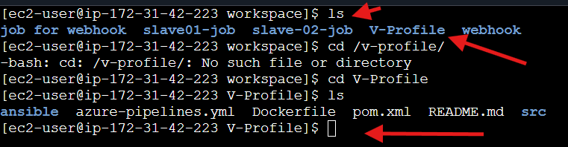

stage2: Sonarqube Integration to check the quality of code
note: sonarqube run on port 9000
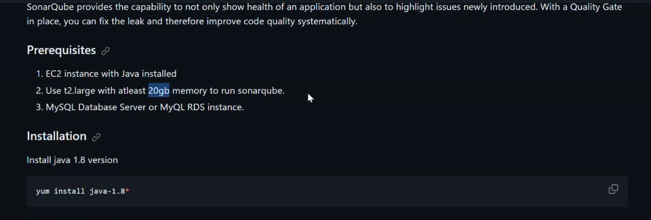

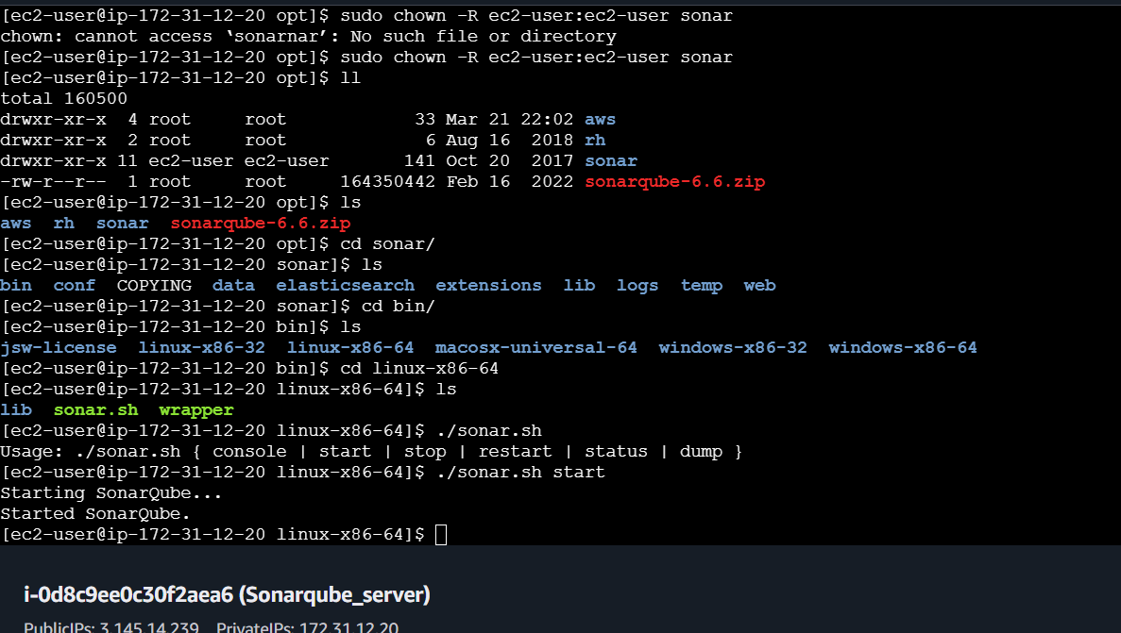

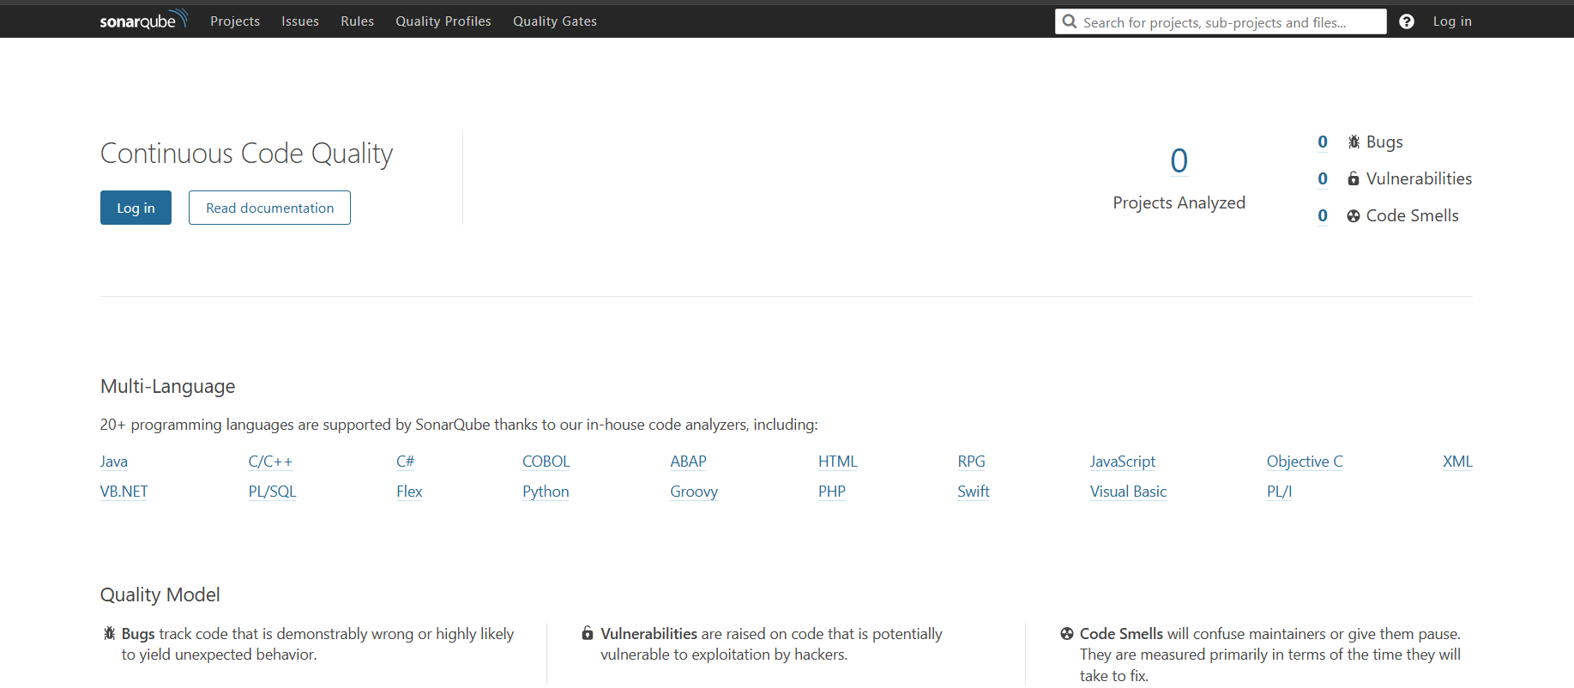
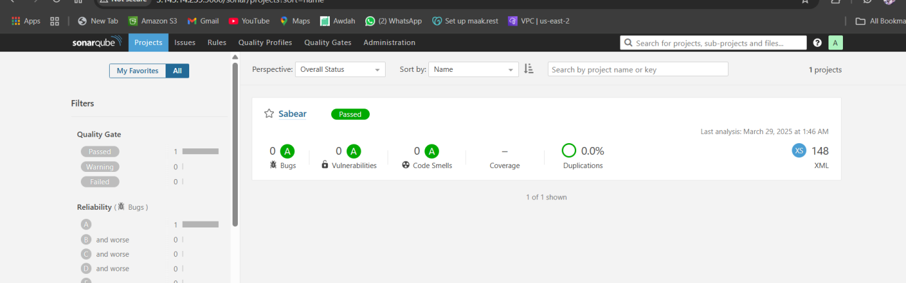

stage3: Slack Integration to send the alerts to slack.
URL: https://github.com/betawins/VProfile-1.git

2) 1) Create one jenkins job using the below code and create three stages.
stage1: Git clone to download the source code.
stage2: Sonarqube Integration to check the quality of code
stage3: Slack Integration to send the alerts to slack.
URL: https://github.com/betawins/hiring-app.git

Git clone done
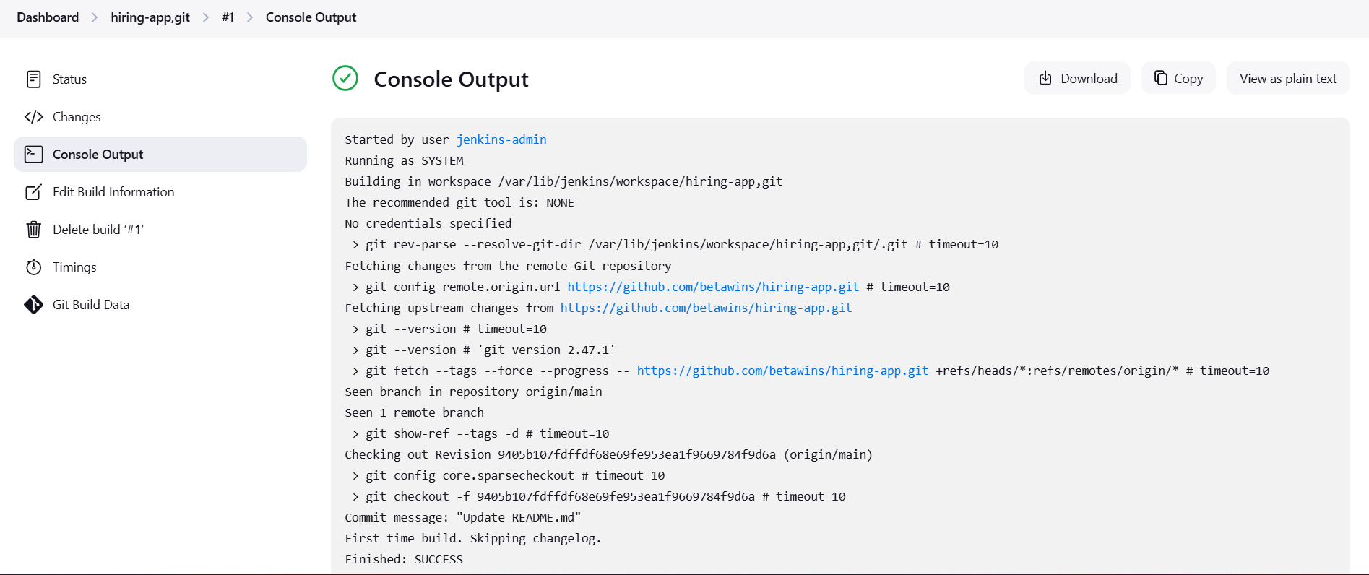

stage2:Sonarqube Integration to check the quality of code

Steps to Integrate SonarQube:

### Prerequisites
1. EC2 instance with Java installed
2. Use t2.large with atleast 20gb memory to run sonarqube.
1. MySQL Database Server or MyQL RDS instance.

### Installation
yum install java-1.8*
yum update
sudo wget https://dev.mysql.com/get/mysql57-community-release-el7-11.noarch.rpm
sudo yum localinstall mysql57-community-release-el7-11.noarch.rpm
rpm --import https://repo.mysql.com/RPM-GPG-KEY-mysql-2022

sudo yum install mysql-community-server
sudo systemctl start mysqld.service
sudo systemctl status mysqld.service

grep 'temporary' /var/log/mysqld.log

mysql -u root -p

Now replace the default password with a new and strong password
ALTER USER 'root'@'localhost' IDENTIFIED BY 'Admin@123';
flush privileges;

Test Using new password
mysql -u root -p

Download & unzip SonarQube 6.0
cd /opt
wget https://binaries.sonarsource.com/Distribution/sonarqube/sonarqube-6.6.zip
unzip sonarqube-6.6.zip
mv /opt/sonarqube-6.6 /opt/sonar

Login to mysql
mysql -u root -p

Create a new sonar database
CREATE DATABASE sonar CHARACTER SET utf8 COLLATE utf8_general_ci;

Create a local and a remote user
CREATE USER sonar@localhost IDENTIFIED BY 'Sonar@123';
CREATE USER sonar@'%' IDENTIFIED BY 'Sonar@123';

Grant database access permissions to users
GRANT ALL ON sonar.* TO sonar@localhost;
GRANT ALL ON sonar.* TO sonar@'%';

check users and databases
show databases;
SELECT User FROM mysql.user;
FLUSH PRIVILEGES;
Exit

### ON EC2 Instance (root user)
ls
cd sonar/
ls
cd conf/
ls
vi sonar.properties

Edit sonar properties file to uncomment and provide required information for below properties.

- File Name: /opt/sonar/conf/sonar.properties
- sonar.jdbc.username=`sonar`
- sonar.jdbc.password=`Sonar@123`
-sonar.jdbc.url=jdbc:mysql://`localhost:3306`/sonar?useUnicode=true&characterEncoding=utf8&rewriteBatchedStatements=true&useConfigs=maxPerformance&useSSL=false
- sonar.web.host=`0.0.0.0`
- sonar.web.context=`/sonar`
exit (switch to ec2 user)
cd /opt/
sudo chown -R ec2-user:ec2-user sonar
ll
cd sonar/bin/linux-x86-64/
ls
bash sonar.sh start
bash sonar.sh status

SonarQube application uses port 9000. access SonarQube from browser

http://52.91.180.136:9000/sonar

Default credentials for sonarqube.
Username : admin
Password: admin

Now install sonar qube scanner

Go to root user
Cd /opt /
wget https://binaries.sonarsource.com/Distribution/sonar-scanner-cli/sonar-scanner-cli-4.6.2.2472-linux.zip
ls
use unzip sonar scanner
rename now [root@ip-172-31-42-223 opt]# mv sonar-scanner-4.6.2.2472-linux /opt/sonar_scanner

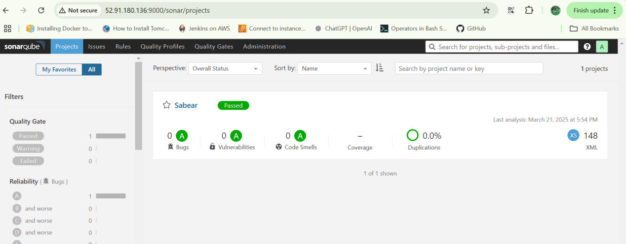

Now go Jenkins browser ,>> manage jeinkins>>plugins
Type in search bar (sonarqube)

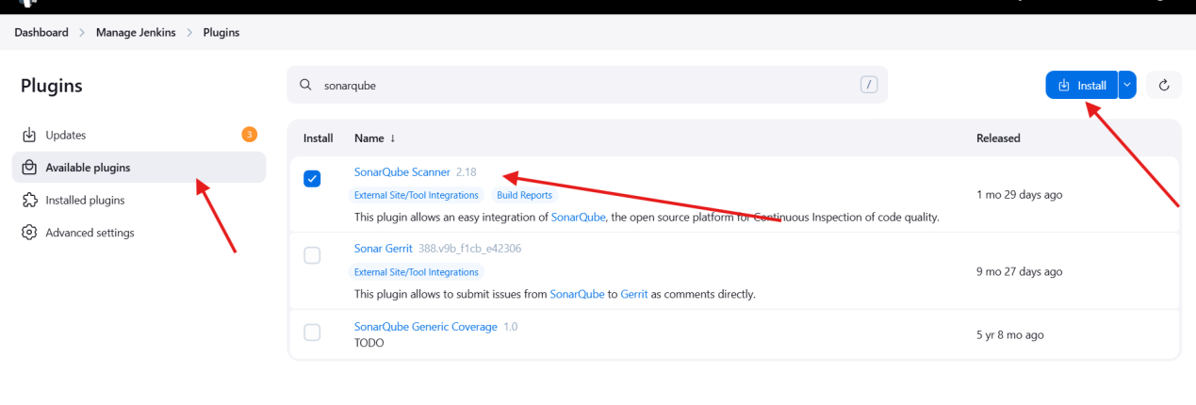

stage3: Slack Integration to send the alerts to slack.

Install Slack Notification plugin in Jenkins Page under Manage Jenkins
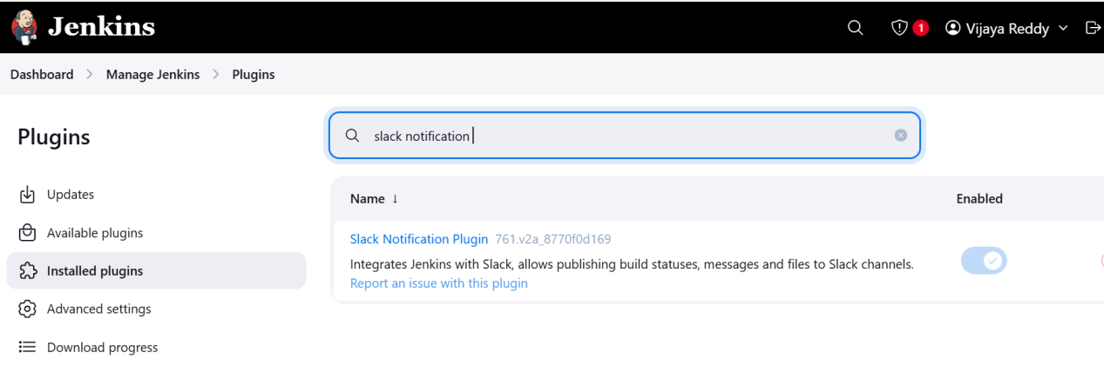

Generat one token , ( sonar-qube.api

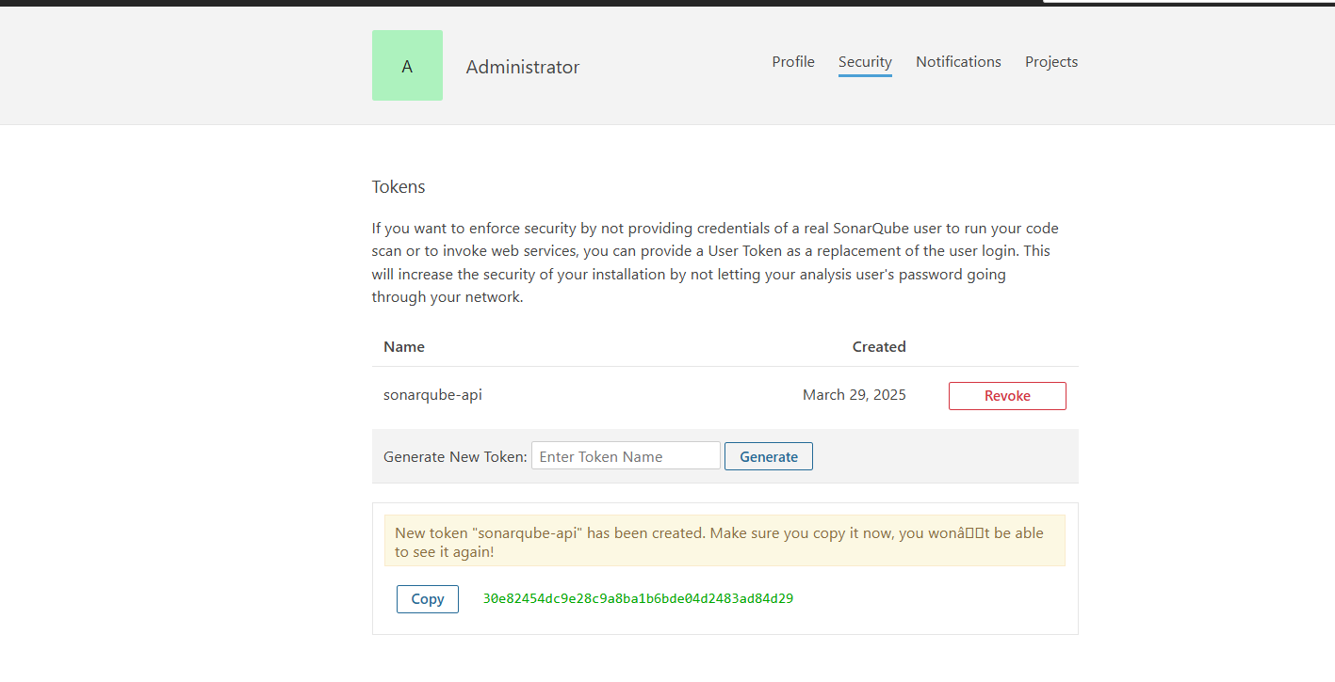
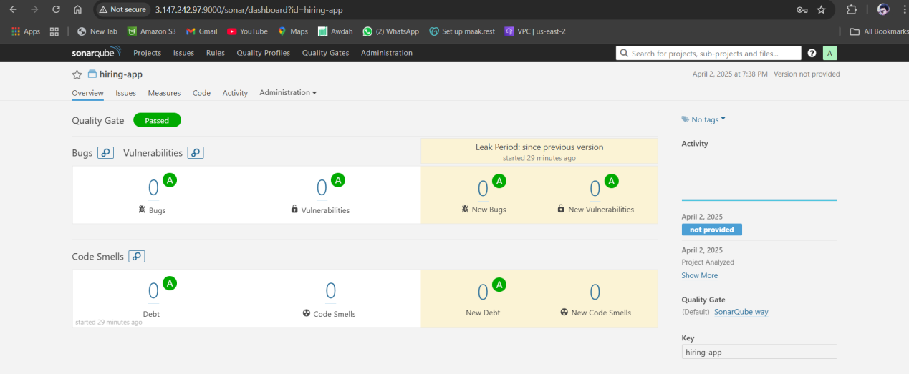

Go to slack, click on 3 dots (…) and select Automations option

